Setting up access to CVS for DBBrowser project on Sourceforge

Basic work flow
The basic work flow is shown below:
CVS Client e.g. Tortoise CVS

Pageant
(has private key)

SSH
Local computer

Remote computer
CVS server
(has public key)

Generate SSH keys
SSH keys can be generated using PuTTy KeyGen program for Windows. Please ensure the key parameters are 'SSH-2 DSA' as shown below:
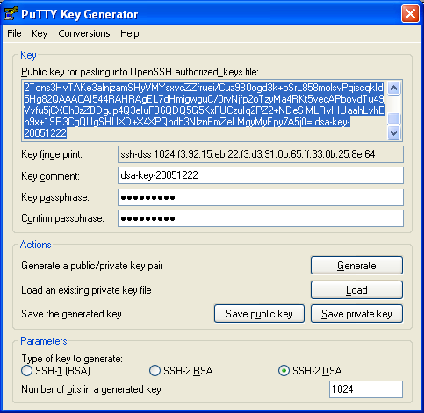

Post the public key on the CVS server
Log in as the administrator for the project and post the SSH key on Sourceforge using this URL:
https://sourceforge.net/account/editsshkeys.php. There is a delay of an hour or so while the keys are processed.

Connect to CVS
You can use any CVS client. On Windows, Pageant must be running for SSH authentication. Pageant will ask you for password when loading a private key. I tried Tortoise CVS. Connect using these parameters:

Protocol: Secure Shell (:ext)
Server: cvs.sourceforge.net
Repository folder: /cvsroot/databasebrowser
Username: your username on sourceforge website (you must have access to the DBBrowser project)
Module: dbbrowser on sourceforge

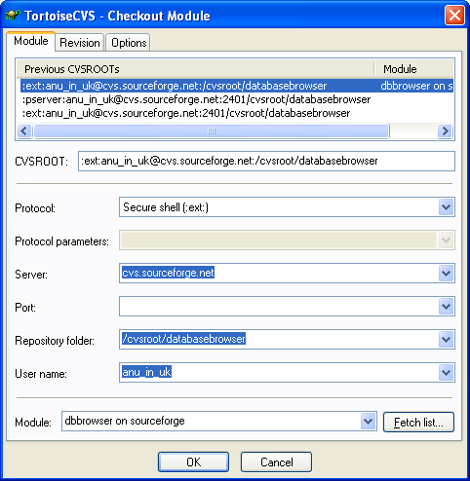
Developer access to CVS
As a developer, you will need to setup CVS client and Pageant. You need to generate your public and private key and send me the public key. I as the project administrator will upload your public key to the CVS server and setup your username. Then you will be able to check in files to CVS.

Please contact me via email: anu_in_uk@hotmail.com for any comments or questions.

Web access
You can have a look at CVS contents via the web. The URL is:
http://cvs.sourceforge.net/viewcvs.py/databasebrowser/

